ASSIGNMENT-1

Task-1:

Write a python program that calculates the factorial of a number without defining my functions

Code and Output:

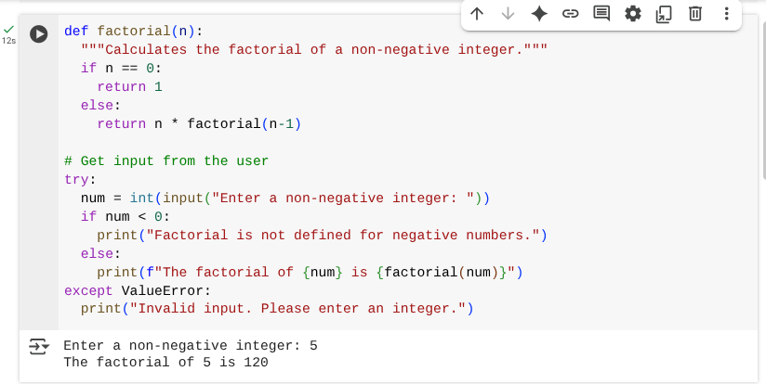

Explanation: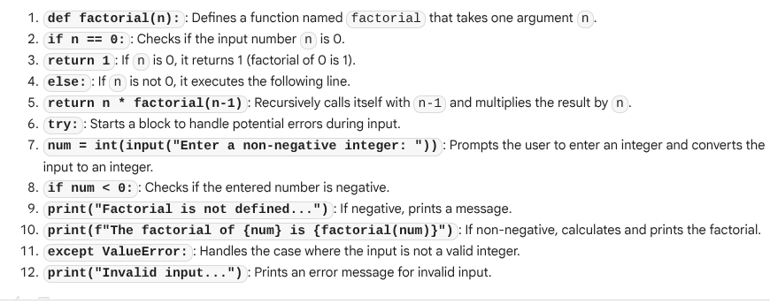

Task-2:

Write a python program that calculates the factorial of a number with function and without function.

Code and Output:

* With function:

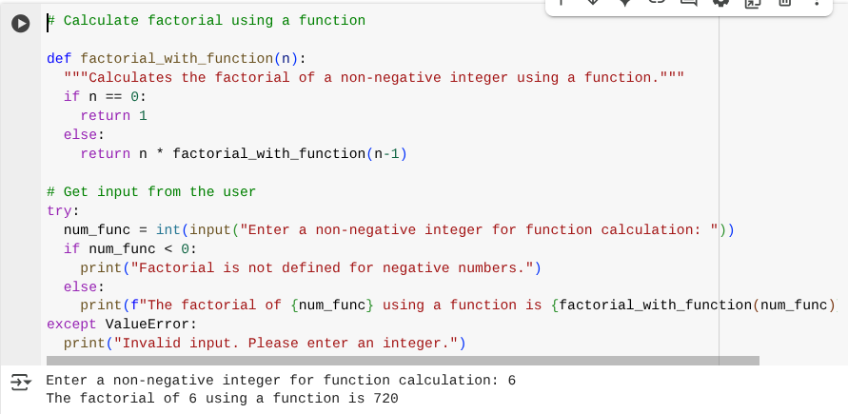

* Without function:

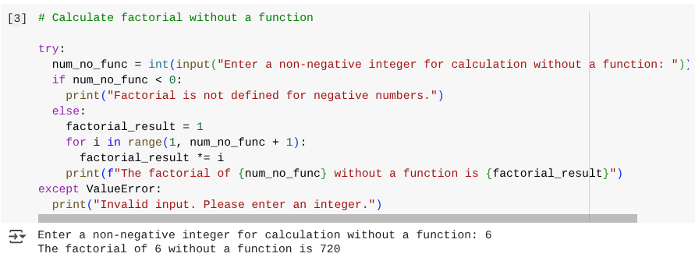

Explanation:

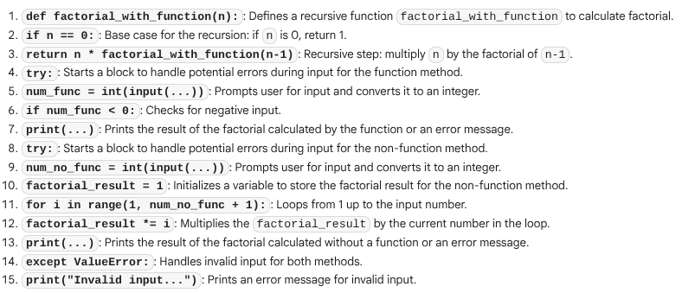

Task-3:

Write a python program that calculates the factorial using both iterative and recursive functions.

Code and Output:

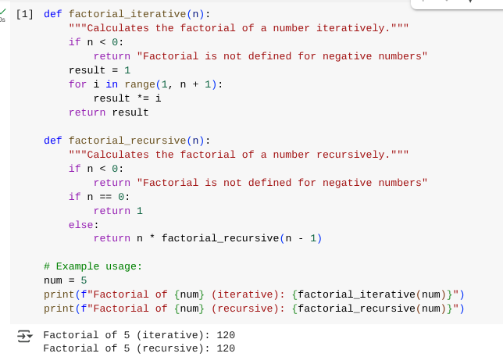

Explanation:

